VAMSI 192011429

EXPERIMENT 3

Configuration of Topologies using Packet Tracer ( Bus, Ring, Hybrid)

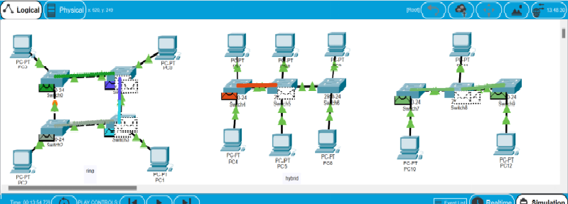

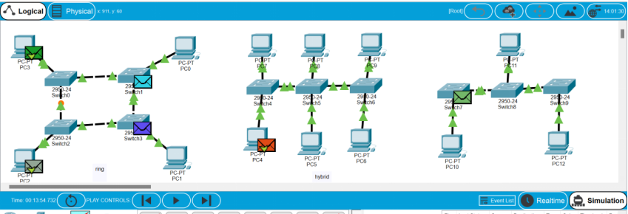

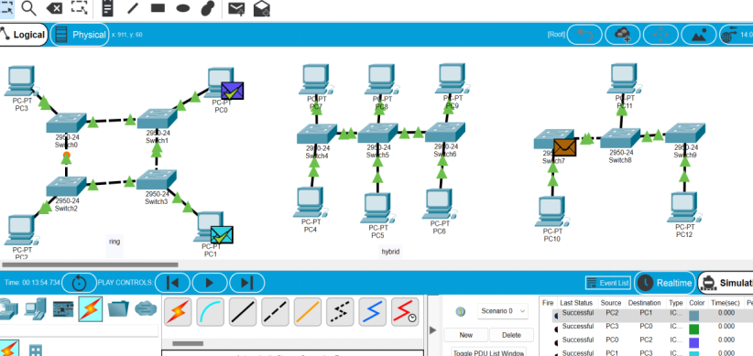

RESULT: The excepted output we have been gotten….